React Hooks

1. useContext Hook
Definition
React Context allows global state management without manually passing props through multiple nested components.
The useContext Hook provides direct access to the nearest Context value.

Why Context Is Needed – The Problem (Prop Drilling)
When deeply nested components need the same state, we traditionally pass data through intermediate components as "props", even when those components do not use the data.
Example:
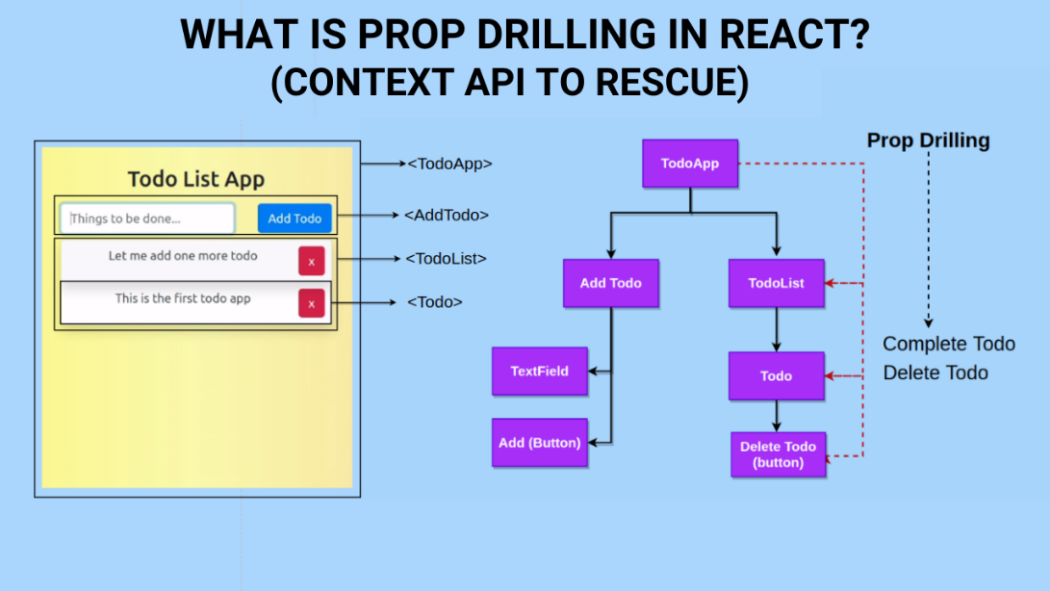
Example – Prop Drilling
function Component1() {
const [user, setUser] = useState("Vita DAC");
return (
<>
<h1>Hello {user}!</h1>
<Component2 user={user} />
</>
);
}
function Component2({ user }) {
return (
<>
<h1>Component 2</h1>
<Component3 user={user} />
</>
);
}
Issues
• Components 2, 3, 4 don't need user, but still must forward it.
• Hard to maintain.
• Not scalable.

2. Solution: React Context + useContext
Steps to Use Context
Step 1: Create Context
const UserContext = createContext();
Step 2: Wrap Components with Context Provider
<UserContext.Provider value={user}>
<Component2 />
</UserContext.Provider>

Step 3: Consume Context in Child Using useContext
const user = useContext(UserContext);

Full Example with Explanation
import { useState, createContext, useContext } from "react";

const UserContext = createContext(); // 1. Create context

function Component1() {
const [user, setUser] = useState("Vita DAC");

return (
// 2. Wrap children in Provider and share "user"
<UserContext.Provider value={user}>
<h1>Hello {user}!</h1>
<Component2 />
</UserContext.Provider>
);
}

function Component5() {
// 3. Access Context using useContext hook
const user = useContext(UserContext);

return (
<>
<h1>Component 5</h1>
<h2>Hello {user} again!</h2>
</>
);
}
Benefits
• No prop drilling
• Cleaner component tree
• Global-like shared state

3. useCallback Hook
Purpose
useCallback memoizes a function so it does not get recreated on every render.
This is important because functions in React are recreated on every render → causes child components to re-render unnecessarily.
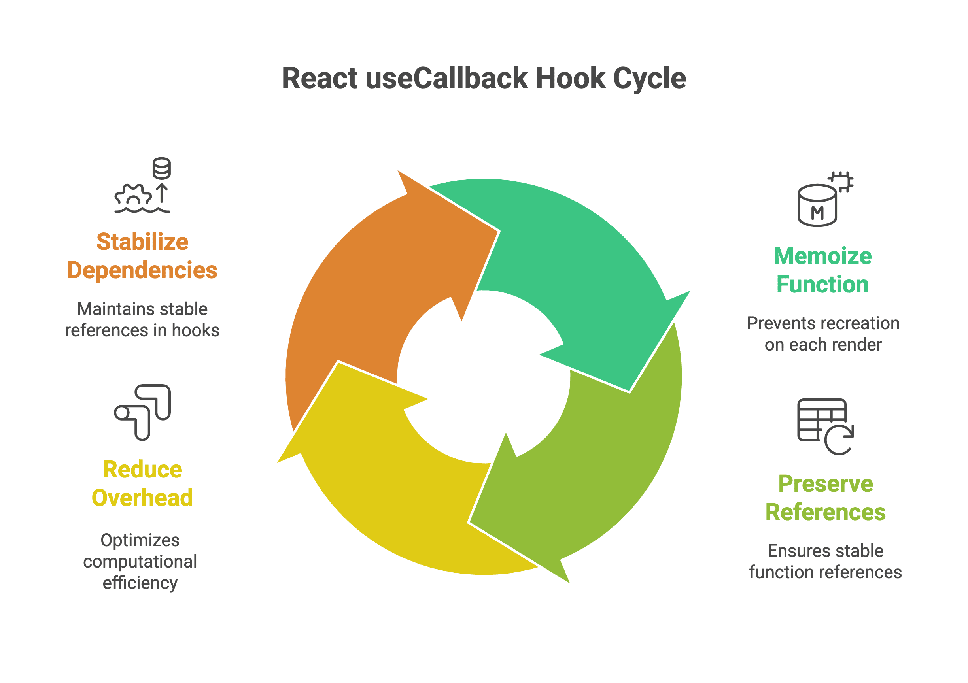
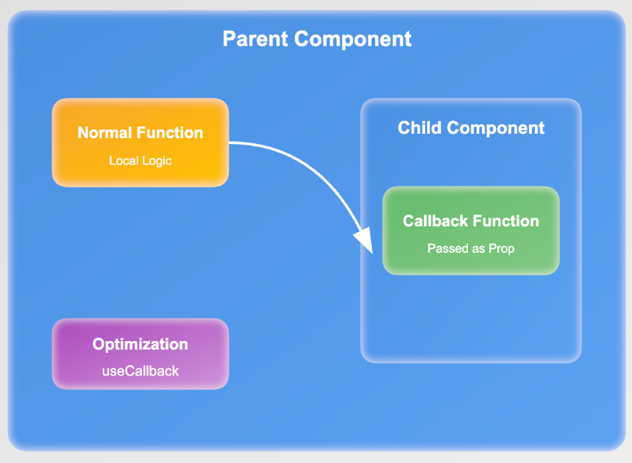

Problem Without useCallback (Referential Equality Issue)
Even if props look the same, React re-renders components when function props change, because every render creates a new function reference.
Example:
const addTodo = () => {
setTodos(t => t + 1);
};

This function is recreated every render, so memoized child components still re-render.

Solution: useCallback
const addTodo = useCallback(() => {
setTodos(t => t + 1);
}, [todos]);

Explanation
• useCallback returns the same memoized function unless dependencies change.
• Child components receiving this function do not re-render unnecessarily.

Full useCallback Example
Parent Component
import { useState, useCallback } from "react";
import Todos from "./Todos";

const App = () => {
const [count, setCount] = useState(0);
const [todos, setTodos] = useState(0);

const increment = () => setCount(c => c + 1);

// Memoized function
const addTodo = useCallback(() => {
setTodos(t => t + 1);
}, [todos]);

return (
<>
<Todos todos={todos} addTodo={addTodo} />
<div>Count: {count} <button onClick={increment}>+</button></div>
</>
);
};

export default App;
Child Component
const Todos = memo(({ todos, addTodo }) => {
console.log("child render");

return (
<>
<h2>My Todos</h2>
<span>{todos}</span>
<button onClick={addTodo}>Add Todo</button>
</>
);
});

Now:
• Child re-renders only when todos change.
• Not when parent count changes.

4. useMemo Hook
Purpose
Memoizes a value, usually a computationally expensive calculation.
Why we need useMemo?
Without memoization, expensive functions run on every render, causing UI lag.
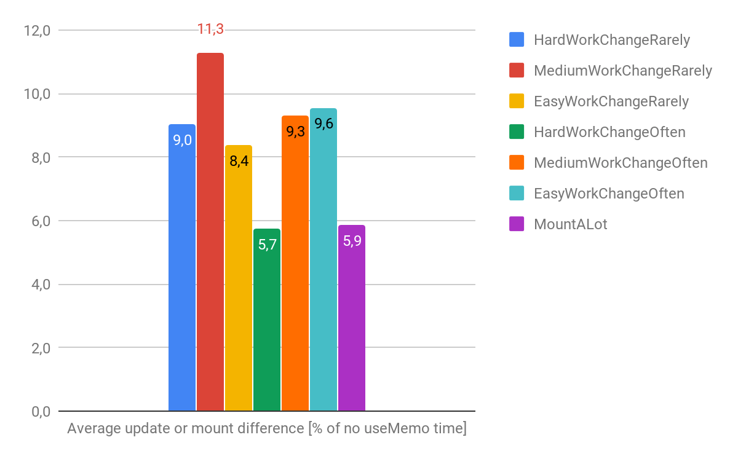
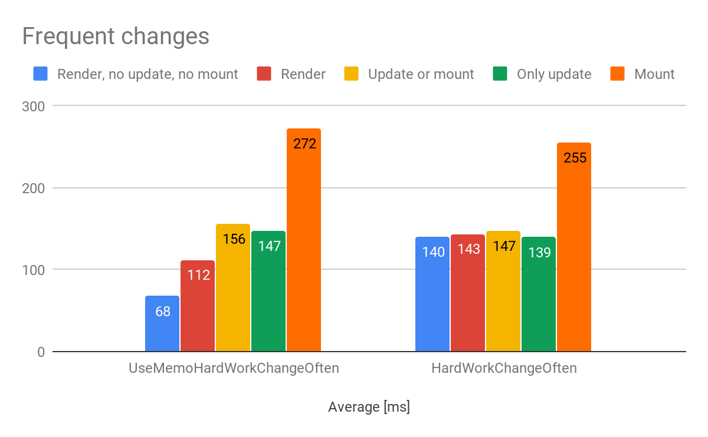

Expensive Function Problem
const calculation = expensiveCalculation(count);
This runs on every render, even when it is not required.

Solution: Wrap in useMemo
const calculation = useMemo(() => expensiveCalculation(count), [count]);
Explanation
• expensiveCalculation runs only when count changes.
• Not when todos update.

Full useMemo Example
import { useState, useMemo } from "react";

const App = () => {
const [count, setCount] = useState(0);
const [todos, setTodos] = useState(0);
// Memoized expensive function
const calculation = useMemo(() => expensiveCalculation(count), [count]);

return (
<>
<button onClick={() => setTodos(t => t + 1)}>Add Todo</button>
<button onClick={() => setCount(c => c + 1)}>+</button>

<h2>Calculation: {calculation}</h2>
</>
);
};
const expensiveCalculation = (num) => {
console.log("Calculating...");
for (let i = 0; i < 1000000000; i++) num++;
return num;
};

5. Custom Hooks
Purpose
Extract reusable logic into separate files.
Rules
• Custom hook name must start with use
• Allows sharing logic without duplicating code
• Keeps components clean

Example: useFetch Custom Hook
Step 1 – Create Hook
import { useState, useEffect } from "react";

const useFetch = (url) => {
const [data, setData] = useState(null);

useEffect(() => {
fetch(url)
.then(res => res.json())
.then(data => setData(data));
}, [url]);

return [data]; // Return value from the hook
};

export default useFetch;

Step 2 – Use Hook in Component
const [data] = useFetch("https://jsonplaceholder.typicode.com/todos");

return (
<>
{data && data.map(item => <p key={item.id}>{item.title}</p>)}
</>
);

Benefits
• Fetch logic reusable
• Cleaner component structure

6. Spread Operator Notes
Object Spread
const obj2 = { ...obj1, newProp: 123 };
Returns new object without altering original.

Array Spread
const numbers2 = [...numbers1, 1, 2, 6];
Note: Arrays can have duplicate values.
Also replaces concat():
const merged = [...arr1, ...arr2];

7. useRef Hook
What it does
• Stores a mutable value that does not trigger re-renders
• Persists value between renders
• Used to access DOM elements directly

1. Using useRef to Store Mutable Values Without Re-render
const count = useRef(0);
useEffect(() => {
count.current += 1; // Does not trigger rerender
});

Explanation
• useRef returns { current: value }
• Updating current does NOT rerender component

2. Accessing DOM Elements
const inputRef = useRef();

const focusInput = () => {
inputRef.current.focus(); // Access DOM node
};
<input ref={inputRef} />
Used when you need imperative control over DOM.

3. Tracking Previous State
const previousValue = useRef("");
useEffect(() => {
previousValue.current = value;
}, [value]);

Summary Table
Hook | Purpose | Re-renders Component? | Typical Use
useContext | Global state access | Yes when value changes | Avoid prop drilling
useCallback | Memoize function | No | Prevent child rerenders
useMemo | Memoize value | No | Expensive calculations
useRef | Store mutable value / DOM ref | No | Count renders, access DOM
Custom Hooks | Reuse logic | Depends | Fetching, timers

